SIMATS ENGINEERING
Department of Computer Science and Engineering
ASSIGNMENT REPORT
Object-Oriented Analysis and UML-Based Design of an
Autonomous Drone-Based Disaster Response and Rescue System (ADDRRS)

Course Code & Name | CSA11 - Object Oriented Analysis and Design
Course Outcomes | CO1, CO2, CO3
Bloom's Taxonomy Level | BL3 - Apply, BL4 - Analyse, BL5 - Evaluate, BL6 - Create
SDG Mapping | SDG 3, SDG 9, SDG 11, SDG 13
Assignment Weightage | 100%
Student Name | ____________________________
Register Number | ____________________________
Date of Submission | ____________________________

Annexure A - Assignment Code of Conduct
I ____________________________________ (Name / Register Number) certify that this submission is my original work and that I have adhered to the guidelines specified for this assessment.
I understand that any violation of academic integrity rules will result in disciplinary action.

Signature of the Student: ______________________ Date: ______________

Table of Contents
1. Problem Analysis and Requirement Summary
2. Actor Identification
3. Use Case Descriptions
4. Use Case Diagram
5. Object and Class Identification
6. Class Diagram
7. Sequence / Interaction Diagram
8. Activity Diagram
9. State Transition Diagram
10. Package Diagram
11. Component Diagram
12. Deployment Diagram
13. Object Responsibility Analysis
14. Design Axioms, Principles and Design Pattern Justification
15. Assumptions and Constraints
16. Requirement-to-Use Case / Class Traceability
17. Implementation / Prototype and Results
18. Reflection on Design Decisions and Learning Outcomes
19. GitHub Upload

1. Problem Analysis and Requirement Summary
Disasters such as floods, earthquakes, industrial accidents, and building collapses create environments that are too dangerous, too large, or too time-critical for human rescue teams to survey unaided. The Autonomous Drone-Based Disaster Response and Rescue System (ADDRRS) is proposed as a software-controlled ecosystem that lets emergency personnel register an incident, define the geographic zones affected by it, and dispatch autonomous drones equipped with cameras and environmental sensors to survey those zones, detect victims and hazards, and relay live data back to a central command system so that rescue teams can be coordinated quickly and safely.
From the given scenario, the system is understood to be a real-time, distributed, safety-critical application in which software objects must represent both administrative concepts (incidents, missions, teams, resources) and physical/autonomous entities (drones, sensors, cameras) that operate with only intermittent human supervision. This dual nature drives the object identification, relationship design, and behavioural modelling carried out in this report.

1.1 Functional Requirements
- FR1: The system shall allow authorized emergency personnel to register a disaster incident with type, severity, and location.
- FR2: The system shall allow coordinators to define one or more affected zones for an incident using geographic coordinates.
- FR3: The system shall authenticate users and enforce role-based access (Coordinator, Operator, Field Team Member).
- FR4: The system shall assign available drones and operators to rescue missions and plan an optimal route to the affected zone.
- FR5: Drones shall autonomously navigate to assigned zones, capture images/video, and collect environmental sensor readings (thermal, gas, etc.).
- FR6: The system shall transmit sensor data and live video feeds from drones to the central command system in real time.
- FR7: The system shall analyse incoming data to detect victims or hazards and automatically generate emergency alerts.
- FR8: The system shall notify and coordinate field rescue teams based on generated alerts.
- FR9: The system shall track and display real-time drone status (location, battery, health) to operators and coordinators.
- FR10: The system shall manage resources (medical kits, vehicles, personnel) associated with a mission.
- FR11: The system shall handle drone failures (loss of signal, low battery, hardware fault) with a defined recovery/emergency-landing procedure.
- FR12: The system shall generate a mission completion report summarizing the incident, zones covered, resources used, and outcomes.

1.2 Non-Functional Requirements
- Real-time communication: telemetry, alerts, and video must reach the command centre with minimal latency.
- Reliability & fault tolerance: the system must detect and gracefully handle drone/communication failures without losing mission data.
- Security: role-based authentication and encrypted communication channels for command and telemetry links.
- Scalability: the architecture must support many concurrent missions, drones, and zones during a large-scale disaster.
- Maintainability & extensibility: new sensor types, drone models, or notification channels should be addable with minimal impact (supported by low coupling / high cohesion design).
- Usability: dashboards for coordinators and operators must present mission-critical information clearly under stress.

1.3 System Boundary
The system boundary encloses the Command Dashboard, Mission/Incident/Alert management services, the telemetry link to drones, and the central data store. Physical rescue action in the field, the drone's flight hardware itself, and third-party weather/GIS data are treated as external to the software boundary but interact with it through well-defined interfaces, as shown in the Use Case Diagram (Section 4) and Deployment Diagram (Section 12).

2. Actor Identification
Actors were identified by analysing who or what initiates, or is affected by, interactions with the system boundary described in the scenario.
Actor | Type | Description
Emergency Coordinator | Primary (Human) | Registers incidents, defines zones, assigns drones/missions, coordinates teams, reviews reports.
Drone Operator | Primary (Human) | Plans routes, monitors and controls drone flight, responds to drone faults.
Field Rescue Team Member | Primary (Human) | Receives alerts, executes on-ground rescue actions, updates rescue status.
Drone | Primary (Autonomous) | Autonomously navigates, captures imagery/sensor data, detects victims/hazards, reports status.
Central Command System | Supporting (System) | Central software boundary that stores data and coordinates all subsystems (system-under-design).
Weather / GIS Service | Secondary (External System) | Supplies terrain, weather, and hazard-map data used to extend route planning.

3. Use Case Descriptions
The following table describes the primary use cases shown in the Use Case Diagram (Section 4), including actors, preconditions, main flow, and postconditions for the most critical scenarios.
UC-1: Register Disaster Incident
Primary Actor: Emergency Coordinator
Precondition: Coordinator is authenticated.
Main Flow: 1) Coordinator opens 'New Incident'. 2) Enters type, severity, location. 3) System validates and creates DisasterIncident. 4) System assigns unique incident ID.
Postcondition: A new DisasterIncident exists and is visible on the dashboard.
UC-2: Assign Drone to Mission
Primary Actor: Emergency Coordinator
Precondition: Incident and at least one affected zone exist; at least one drone is idle.
Main Flow: 1) Coordinator selects zone. 2) System lists available drones/operators. 3) Coordinator assigns drone + operator. 4) System creates RescueMission and triggers route planning (includes UC-5).
Postcondition: RescueMission is created with status 'Assigned'.
UC-5: Plan Route
Primary Actor: Drone Operator / System
Precondition: Mission and zone coordinates are available.
Main Flow: 1) System/operator requests a route. 2) System optionally queries Weather/GIS service (extend) for hazards. 3) Route with waypoints is computed and stored.
Postcondition: A Route object is linked to the mission.
UC-9: Detect Victim / Hazard
Primary Actor: Drone
Precondition: Drone is in 'Scanning' state within an assigned zone.
Main Flow: 1) Drone continuously captures imagery/sensor readings. 2) Onboard/edge analysis flags anomalies. 3) On a positive detection, the system includes UC-10 (Generate Alert).
Postcondition: Victim/hazard record created and linked to the zone.
UC-10: Generate Emergency Alert
Primary Actor: Central Command System
Precondition: A victim or hazard has been detected, or a drone fault has occurred.
Main Flow: 1) System creates an Alert with type and priority. 2) System notifies the relevant Field Rescue Team(s) (UC-11).
Postcondition: Alert is logged and at least one team is notified.
UC-13: Handle Drone Failure
Primary Actor: Drone / Drone Operator
Precondition: Drone reports a fault (signal loss, critical battery, hardware error).
Main Flow: 1) Drone/telemetry service detects the fault condition. 2) System switches drone to 'Fault / Emergency Landing' state. 3) Operator is notified and may take manual control. 4) System logs the event for the mission report.
Postcondition: Drone is safely landed/recovered or marked out-of-service; mission status updated.
UC-15: Generate Mission Completion Report
Primary Actor: Emergency Coordinator
Precondition: Mission status is 'Completed'.
Main Flow: 1) Coordinator requests report. 2) System compiles incident, zone, resource, and outcome data (includes UC-12, Manage Resources). 3) Report is generated and stored.
Postcondition: A MissionReport is available for review/export.

4. Use Case Diagram
The diagram below models the system boundary of ADDRRS together with its primary actors and use cases, including <<include>> relationships (e.g., every workflow includes authentication; victim detection includes alert generation) and <<extend>> relationships (e.g., route planning is extended by an optional weather/GIS check; drone monitoring is extended by fault handling when a fault condition arises).
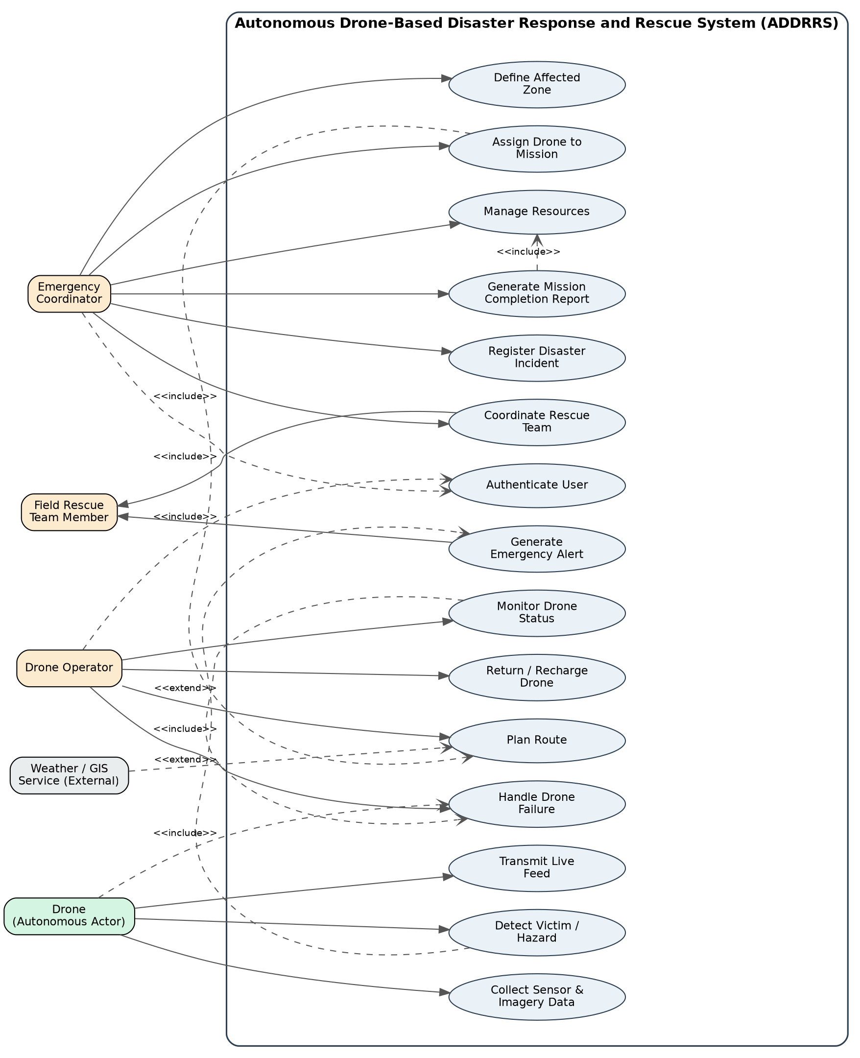
Figure 4.1: Use Case Diagram - ADDRRS

5. Object and Class Identification
Candidate classes were identified using noun-phrase analysis of the problem statement, then filtered against CRC (Class-Responsibility-Collaborator) criteria to remove duplicates, attributes mistaken for classes, and out-of-scope concepts.
Class | Category | Key Responsibility
User (abstract) | Actor/Entity | Common identity & authentication behaviour for all human roles.
EmergencyCoordinator | Entity | Registers incidents/zones, assigns missions, oversees resources & reports.
DroneOperator | Entity | Plans routes and operates/monitors assigned drones.
FieldTeamMember | Entity | Receives alerts and reports on-ground rescue status.
DisasterIncident | Entity | Represents a registered disaster event and groups its zones.
AffectedZone | Entity | Represents a geographic area needing survey/rescue, with a risk level.
RescueMission | Control/Entity | Coordinates the assignment of drone + route + resources to a zone; tracks mission status.
Drone | Entity (Autonomous) | Navigates, owns sensors/camera, reports telemetry, executes flight commands.
Camera | Entity | Captures images/video from the drone.
Sensor | Entity | Captures environmental readings (thermal, gas, etc.).
SensorData | Entity | Immutable record of a single sensor/camera capture with timestamp.
Route | Entity | Ordered waypoints computed for a mission.
Victim | Entity | Represents a detected person requiring rescue, with location & condition.
Alert | Control/Entity | Represents a generated emergency notification with type/priority.
Resource | Entity | Represents allocatable assets (medical kits, vehicles, personnel count).
CommandCenter | Control (Boundary) | Central coordinating object; monitors drones, dispatches missions.
MissionReport | Entity | Summarizes a completed mission for review/export.

5.1 Object Identification Approach
Object identification followed Coad & Yourdon's classification categories: (1) physical/tangible things - Drone, Camera, Sensor; (2) roles - EmergencyCoordinator, DroneOperator, FieldTeamMember; (3) events/transactions - RescueMission, Alert, SensorData capture; (4) interactions/associations - Route (links mission to a zone); and (5) places - AffectedZone. Attributes that only describe another class (e.g., battery level, GPS coordinates) were kept as attributes rather than promoted to classes, keeping the model at an appropriate level of granularity.

6. Class Diagram
The Class Diagram formalizes the classes from Section 5 together with their attributes, methods, multiplicities, and relationship types (generalization, composition, aggregation, association, and dependency).
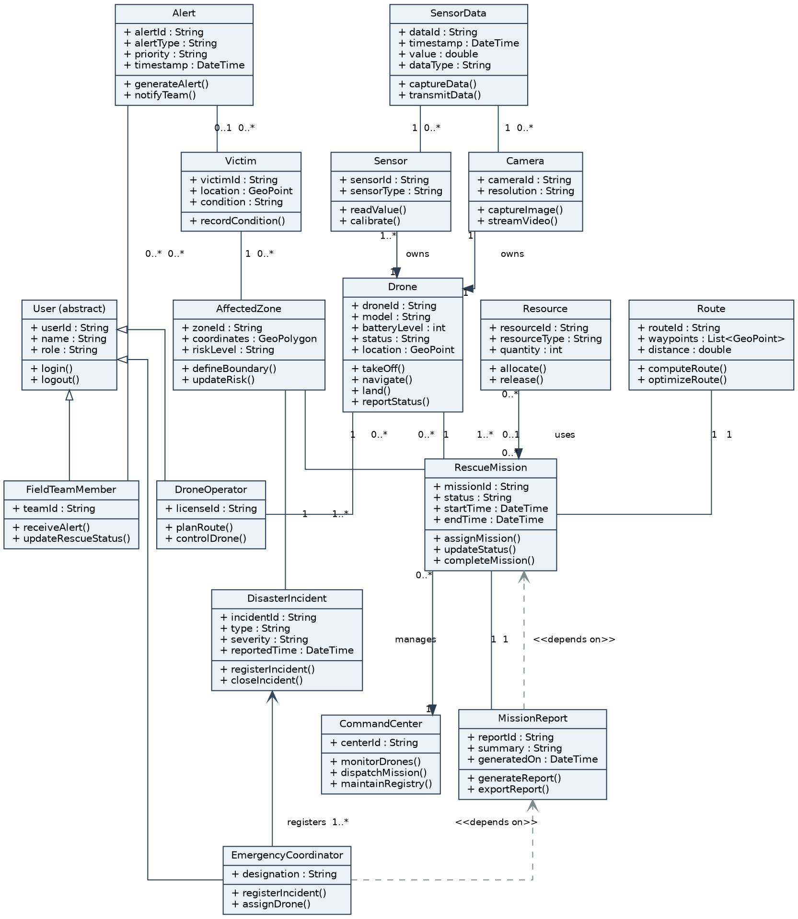
Figure 6.1: Class Diagram - ADDRRS

6.1 Relationship Justification
Relationship | Type | Justification
EmergencyCoordinator / DroneOperator / FieldTeamMember -> User | Generalization | All three roles share identity/authentication behaviour; modelled once in the superclass to avoid duplication.
Drone -> Camera, Drone -> Sensor | Composition | A Camera/Sensor is physically part of a specific Drone and has no independent lifecycle if the drone is decommissioned.
RescueMission -> Resource | Aggregation | Resources (vehicles, kits, personnel) can exist and be reused independently of any one mission.
RescueMission -> Drone, RescueMission -> Route | Association | A mission is temporarily linked to a drone and a computed route; the drone and route can exist without that specific mission afterward.
MissionReport -> RescueMission | Dependency | A report is generated from mission data at a point in time but does not permanently hold a structural reference.

7. Sequence / Interaction Diagram
The sequence diagram below traces one full scenario: a coordinator registers an incident and zone, a drone is assigned and scans the zone, a victim is detected, an alert is raised to a field team, and the mission is closed out with a report - covering the include relationships from the Use Case Diagram end-to-end.
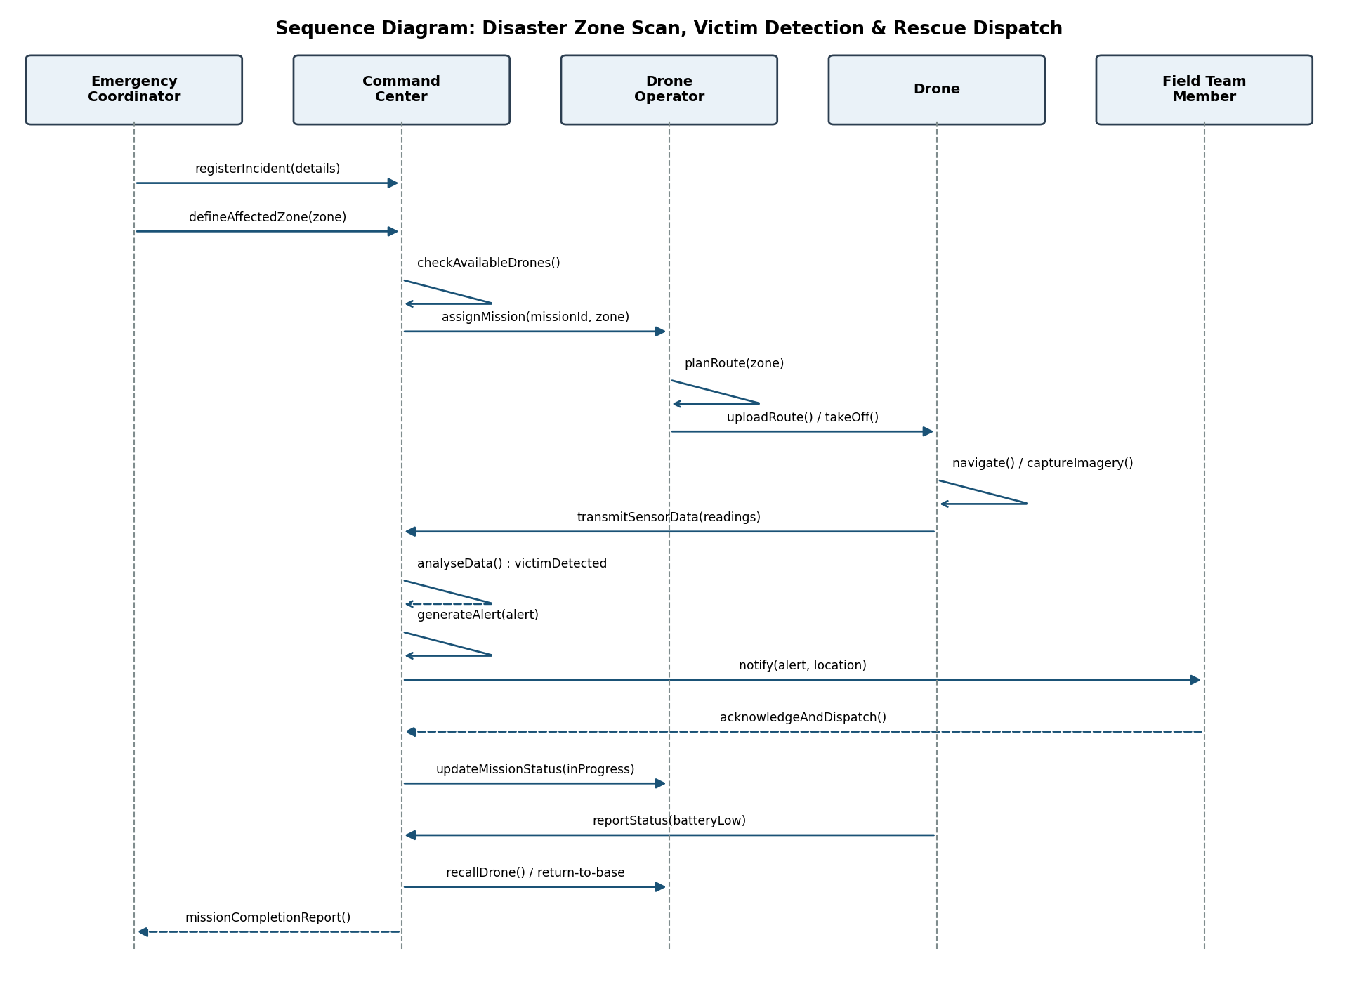
Figure 7.1: Sequence Diagram - Zone Scan, Victim Detection & Rescue Dispatch

8. Activity Diagram
The activity diagram models the end-to-end disaster-response workflow, including the decision points for drone availability, victim/hazard detection, and mission completion/battery status that drive the corresponding state transitions in Section 9.
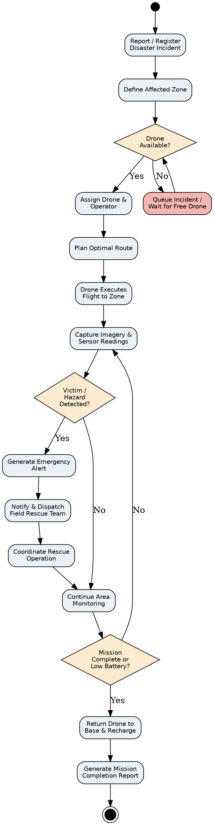
Figure 8.1: Activity Diagram - Disaster Response Workflow

9. State Transition Diagram
The Drone class exhibits the richest lifecycle in the system and is therefore chosen for the state transition diagram. States progress from Idle through pre-flight checks, en-route travel, scanning, optional victim-assistance mode, and return-to-base/charging, with a dedicated Fault state reachable from any active flight state.
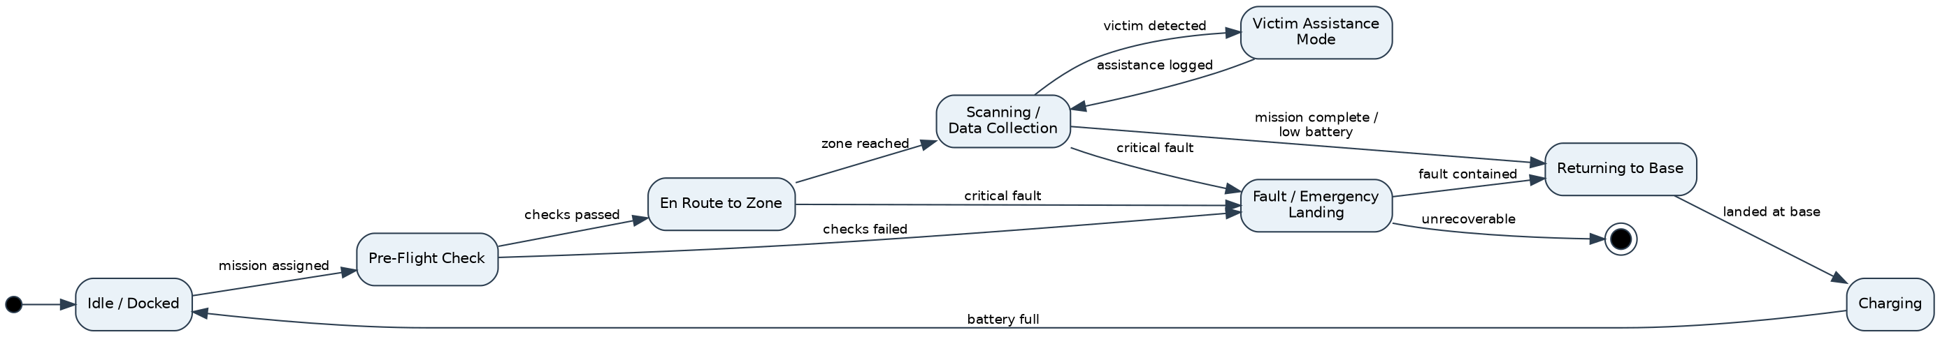
Figure 9.1: State Transition Diagram - Drone Lifecycle

10. Package Diagram
The system is decomposed into ten cohesive packages, separating presentation, domain services, and persistence. Dependencies point from higher-level workflow packages toward lower-level, more stable packages (e.g., Persistence), which keeps coupling directional and acyclic.
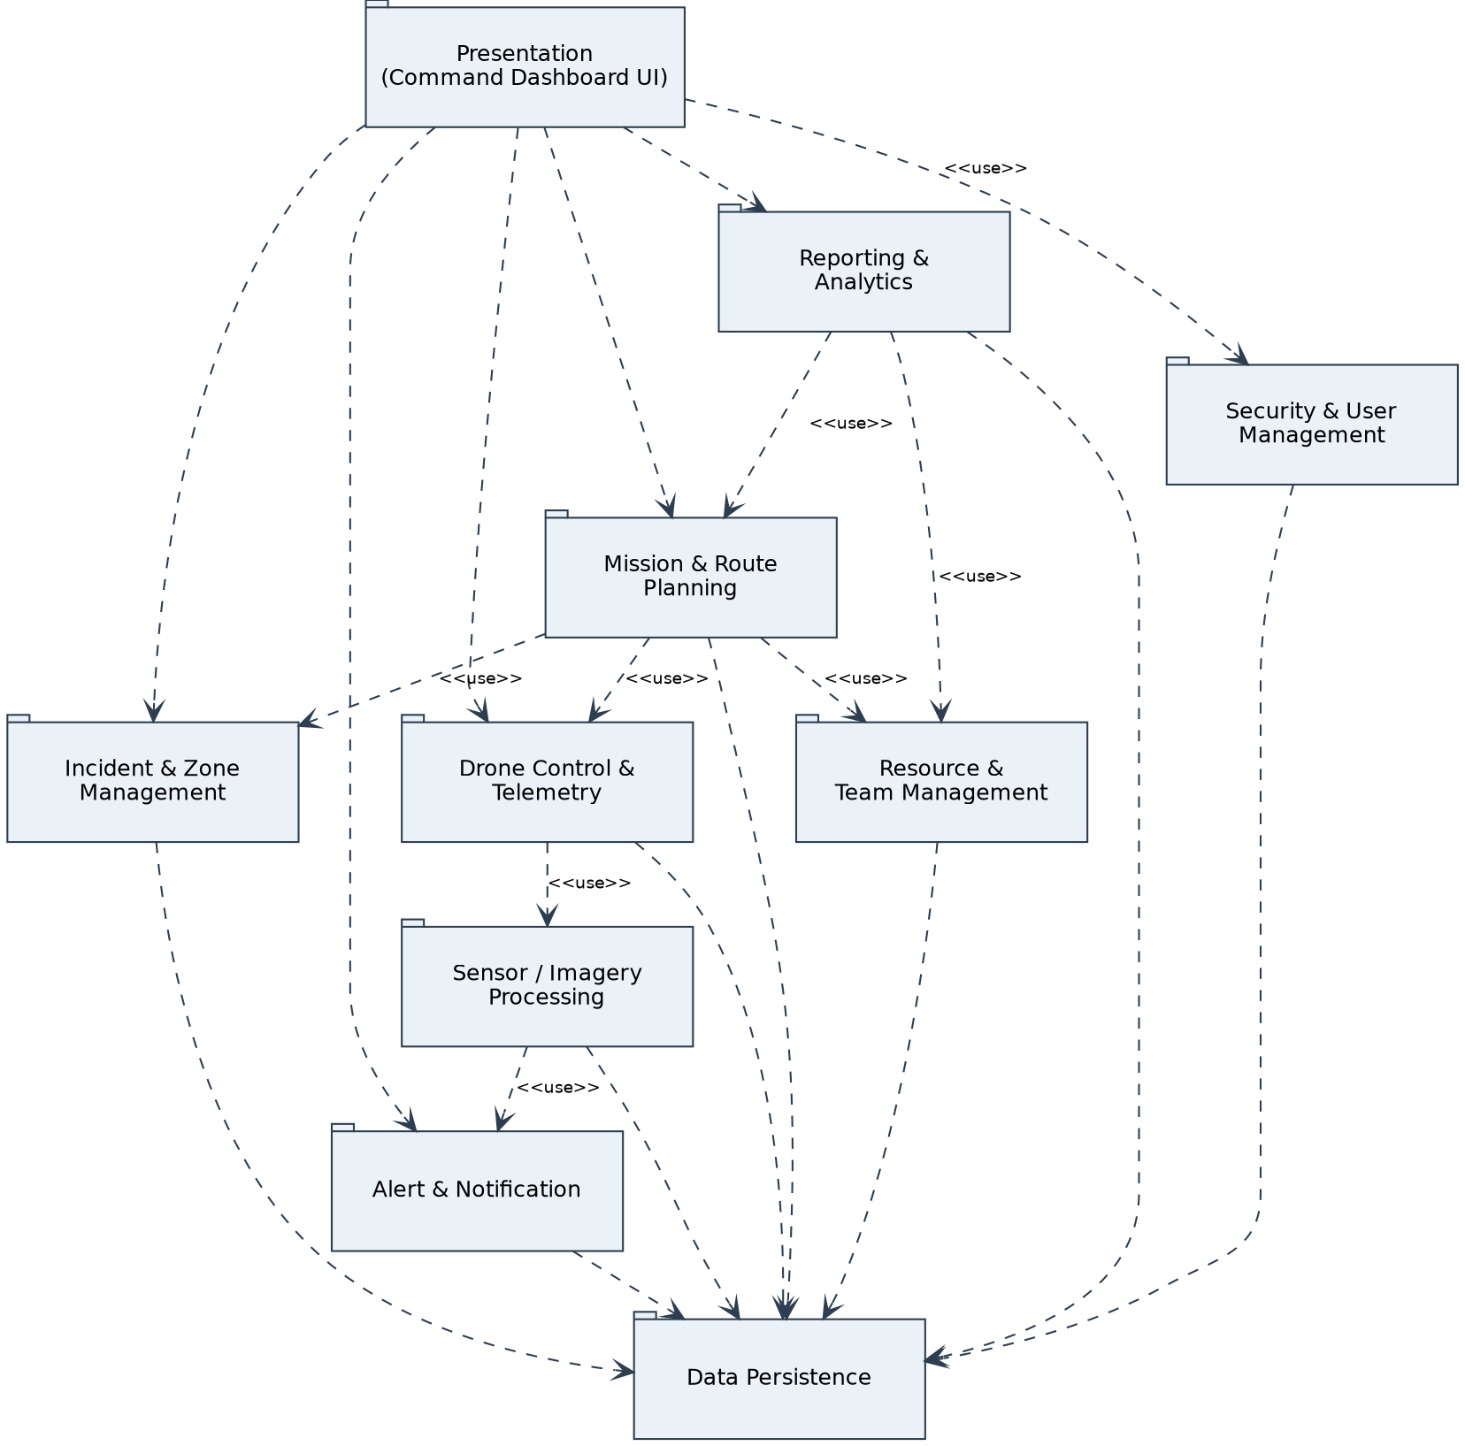
Figure 10.1: Package Diagram - ADDRRS Modules

11. Component Diagram
The component diagram refines the package view into deployable software components and their provided/required interfaces, showing the Command Dashboard as the sole client-facing component and the Telemetry & Communication Service as the single integration point with the drone's onboard component.
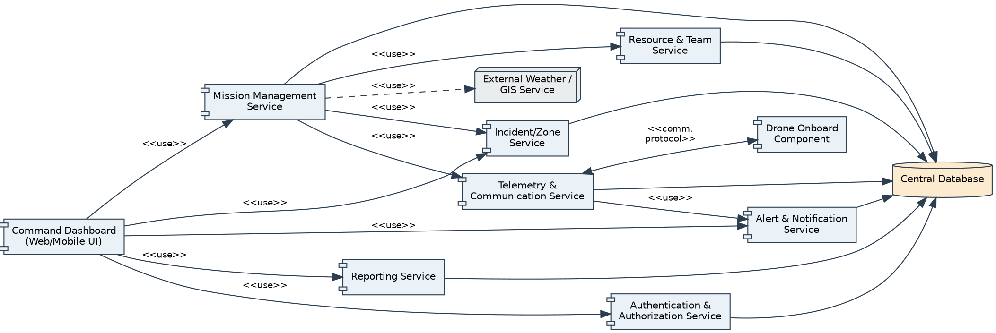
Figure 11.1: Component Diagram - ADDRRS

12. Deployment Diagram
Four physical/logical nodes are identified: the embedded Drone node (flight controller, edge-AI victim detection, sensor hardware), the Ground Control Station used by the operator, the Command Cloud/Data Center hosting application and database servers, and the Command Center Clients (coordinator web dashboard and field team mobile app). The external Weather/GIS provider is accessed over HTTPS from the application server.
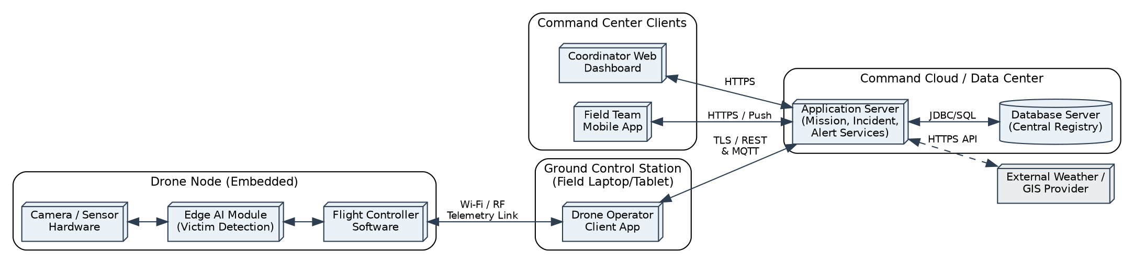
Figure 12.1: Deployment Diagram - ADDRRS

13. Object Responsibility Analysis
Responsibilities were assigned using CRC-style analysis so each class has a clear, singular purpose (supporting high cohesion) and collaborates with the minimum necessary set of other classes (supporting low coupling).
Class | Primary Responsibility | Key Collaborators
CommandCenter | Own the master registry of incidents, zones, missions and drones; dispatch missions; aggregate telemetry. | DisasterIncident, RescueMission, Drone
RescueMission | Bind a drone, route, zone, and resources together for the lifetime of one rescue effort; track status. | Drone, Route, AffectedZone, Resource
Drone | Execute flight commands, own its Camera/Sensors, report telemetry and detected anomalies. | Camera, Sensor, SensorData, CommandCenter
Alert | Encapsulate a single emergency notification and know how to notify the correct recipients. | FieldTeamMember, Victim
MissionReport | Summarize a completed mission for accountability and continuous improvement. | RescueMission, Resource

Assigning route computation to a dedicated Route class (rather than to Drone or RescueMission directly) follows the Expert pattern - Route has the waypoint data needed to justify owning computeRoute()/optimizeRoute() - and keeps Drone focused purely on flight execution.

14. Design Axioms, Principles and Design Pattern Justification

14.1 Design Axioms (Suh's Axiomatic Design)
Axiom 1 (Independence Axiom): each functional requirement is satisfied by an independent design parameter/class wherever possible - e.g., route planning (Route), telemetry (Drone/SensorData), and alerting (Alert) are separate classes rather than one large 'MissionManager' God class, so a change to alerting logic does not ripple into route computation.
Axiom 2 (Information Axiom): among independent designs, the simplest (lowest information content) is preferred - e.g., Drone state is modelled with a single 'status' attribute plus a well-defined state machine (Section 9) rather than multiple boolean flags that could produce inconsistent combinations.

14.2 Core Design Principles Applied
High Cohesion: Each class has one clear purpose (e.g., Alert only represents/dispatches a notification; it does not also manage resources).
Low Coupling: Classes collaborate through a small number of well-defined associations (e.g., RescueMission depends on Route and Drone but not on UI classes).
Encapsulation: Internal state (battery level, sensor calibration) is only modified through methods (e.g., reportStatus(), calibrate()), not exposed directly.
Abstraction: The abstract User class hides common authentication behaviour behind a simple interface used identically by all three role subclasses.
Single Responsibility Principle (SRP): MissionReport only formats/exports data; it does not also change mission state.
Open/Closed Principle (OCP): New sensor types can be added by extending Sensor without modifying Drone or SensorData.
Liskov Substitution: Any User subclass (Coordinator/Operator/FieldTeamMember) can be used wherever authentication behaviour is required.

14.3 Design Patterns Applied
Pattern | Problem Addressed | Application in ADDRRS
Observer | CommandCenter must react whenever a Drone reports new telemetry/alerts without polling. | Drone (subject) notifies CommandCenter/Dashboard (observers) on status change, decoupling drones from specific UI clients.
State | Drone behaviour differs sharply per lifecycle state (Idle, Scanning, Fault, etc.). | Encapsulates state-specific behaviour/transitions (Section 9) instead of large conditional blocks in Drone.
Strategy | Route optimization may need different algorithms (shortest path vs. hazard-avoiding) depending on conditions. | optimizeRoute() delegates to an interchangeable routing strategy, satisfying OCP.
Factory Method | Different Alert subtypes (victim-detected, drone-fault, hazard) must be created consistently. | An AlertFactory centralizes creation logic so RescueMission/Drone do not need to know alert construction details.
Facade | The Command Dashboard needs a simple entry point to many services (Incident, Mission, Alert, Reporting). | A CommandCenter/Facade component (Section 11) exposes a simplified interface, reducing UI coupling to internal services.

15. Assumptions and Constraints

15.1 Assumptions
- Drones are equipped with GPS, at least one camera, and at least one environmental sensor, and can maintain an intermittent telemetry link to the ground control station.
- Emergency personnel have network connectivity to the Command Dashboard during operations; brief link loss is tolerated and does not crash the drone's autonomous behaviour.
- Victim/hazard detection uses an onboard or edge-AI analysis step; the accuracy of that model is outside the scope of this OOAD exercise and is treated as a black-box collaborator.
- A single Central Database is sufficient for the scope of this design; distributed/replicated persistence is a future scaling concern, not part of the current class design.
- Field Rescue Team members carry a mobile device capable of receiving push notifications.

15.2 Constraints
- The design must clearly separate the system boundary, human actors, and autonomous components (Drone) as required by the problem statement.
- All UML diagrams must remain mutually consistent with the identified use cases (see Section 16 traceability).
- Real-time communication constraints limit how much processing can be pushed to the drone versus the command centre; time-critical detection logic is kept on the edge (Drone/EdgeAI), while heavier analytics remain server-side.
- Security constraints require authenticated, role-based access and encrypted telemetry, which shaped the inclusion of an explicit Authenticate User use case and Security & User Management package.
- Reliability constraints require an explicit Fault/Emergency-Landing state rather than allowing undefined behaviour on failure (Section 9).

16. Requirement-to-Use Case / Class Traceability
The table below demonstrates that every functional requirement from Section 1.1 is realized by at least one use case and implemented by at least one class, ensuring the model is complete and consistent.
Requirement | Use Case(s) | Realizing Class(es)
FR1 | UC-1 Register Disaster Incident | DisasterIncident, EmergencyCoordinator
FR2 | UC-1 (zone definition step) | AffectedZone
FR3 | Authenticate User (included by all UCs) | User, EmergencyCoordinator, DroneOperator, FieldTeamMember
FR4 | UC-2 Assign Drone to Mission, UC-5 Plan Route | RescueMission, Drone, Route
FR5 | UC-6 Monitor Drone Status, UC-7 Collect Sensor Data | Drone, Camera, Sensor, SensorData
FR6 | UC-8 Transmit Live Feed | Drone, SensorData, CommandCenter
FR7 | UC-9 Detect Victim/Hazard, UC-10 Generate Alert | Victim, Alert, SensorData
FR8 | UC-11 Coordinate Rescue Team | Alert, FieldTeamMember
FR9 | UC-6 Monitor Drone Status | Drone, CommandCenter
FR10 | UC-12 Manage Resources | Resource, RescueMission
FR11 | UC-13 Handle Drone Failure | Drone (Fault state), DroneOperator
FR12 | UC-15 Generate Mission Completion Report | MissionReport, RescueMission

17. Implementation / Prototype and Results
To validate that the identified classes and responsibilities are implementable and behave as intended, a lightweight Python console prototype was built covering the core scenario traced in the Sequence Diagram (Section 7): registering an incident, defining zones, assigning a drone to a mission, scanning zones, detecting a possible victim via sensor thresholds, raising an alert, and generating a mission report. The full source (addrrs_prototype.py) is included in the project's GitHub repository (Section 19).

17.1 Key Class Excerpt
class RescueMission:
def __init__(self, mission_id, incident, drone):
self.mission_id = mission_id
self.incident = incident
self.drone = drone
self.status = "Assigned"
def execute(self):
self.status = "In Progress"
self.drone.take_off()
for zone in self.incident.zones:
readings = self.drone.scan_zone(zone)
if readings.get("Thermal", 0) > 38:
alert = Alert("Possible Victim Detected", "HIGH")
alert.notify_team("Field Rescue Team Alpha")
self.drone.return_to_base()
self.status = "Completed"

17.2 Sample Execution Output
[Incident INC-101] zone Z1 defined (13.0827N,80.2707E), risk=HIGH
[Incident INC-101] zone Z2 defined (13.0900N,80.2750E), risk=MODERATE
--- Mission M-2026-01 started (incident INC-101) ---
[Drone DR-07] taking off, status -> En Route
[Drone DR-07] scanning Z1: {'Thermal': 23.4, 'Gas': 41.2}, battery=85%
[Drone DR-07] scanning Z2: {'Thermal': 39.1, 'Gas': 26.4}, battery=70%
[Alert AL-001] 'Possible Victim Detected' (priority=HIGH) sent to Field Rescue Team Alpha
[Drone DR-07] returning to base, battery=70%
--- Mission M-2026-01 status -> Completed ---
Mission Report [M-2026-01]
Incident : INC-101 (Flood, severity=High)
Drone Used : DR-07 (Quad-X200)
Zones : ['Z1', 'Z2']
Final Battery: 70%
Status : Completed
The trace confirms that: (a) zone definition correctly nests under an incident, (b) drone battery is consumed per scan as modelled by the 'battery low' transition in Section 9, (c) an Alert is only raised when the sensor threshold condition of UC-9 is met, and (d) the final MissionReport aggregates exactly the fields traced in Section 16 (FR12).

18. Reflection on Design Decisions and Learning Outcomes
Working through this assignment reinforced that Object-Oriented Analysis and Design is most valuable at the boundary between human-operated and autonomous parts of a system: deciding whether the Drone should be modelled as an actor, an entity class, or both (it is both - an actor in the Use Case Diagram and a rich, stateful class in the Class/State diagrams) shaped almost every later diagram. Choosing composition for Drone-Camera/Sensor versus aggregation for RescueMission-Resource also clarified how lifecycle dependency, not just 'has-a' phrasing, should drive relationship selection.
Applying design axioms and patterns (Observer for telemetry, State for drone lifecycle, Strategy for route optimization) showed how the same functional requirement can be met with very different coupling/cohesion outcomes, and why the axiomatic 'independence' criterion is a practical checklist rather than an abstract rule. Building the small working prototype in Section 17 was particularly useful: implementing RescueMission.execute() surfaced that the alert-generation condition belongs logically closer to SensorData/Drone than to RescueMission, prompting a refinement in how responsibilities were assigned in Section 13.
In terms of Sustainable Development Goals, this system directly supports SDG 3 (Good Health and Well-being) and SDG 11 (Sustainable Cities and Communities) by reducing the time to locate and assist disaster victims; SDG 13 (Climate Action) is relevant because floods, storms, and other climate-linked disasters are a primary use case; and SDG 9 (Industry, Innovation and Infrastructure) is reflected in the use of autonomous, sensor-driven infrastructure to modernize emergency response. Overall, the exercise demonstrated that rigorous OOAD is not just documentation overhead - the traceability matrix in Section 16 and the working prototype in Section 17 both depended directly on decisions made during actor and class identification in Sections 2 and 5.

19. GitHub Upload
The complete assignment artefacts - this report, all UML diagram source files, and the working prototype - are organized for upload to a public or classroom GitHub repository as follows:
ADDRRS-OOAD-Assignment/
├── README.md (project overview, how to run the prototype)
├── docs/
│ ├── ADDRRS_Assignment.docx
│ ├── ADDRRS_Assignment.pdf
│ └── diagrams/ (usecase, class, sequence, activity,
│ state, package, component, deployment .png)
└── src/
└── addrrs_prototype.py (working console prototype)

GitHub Repository Link: ____________________________________________
(Insert the HTTPS link to your repository here after uploading, and also paste the same link into the Google Classroom submission comment box.)

